วิทยาลัยเทคนิคสัตหีบ
ข้อสอบเก็บคะแนนภาคเรียนที่ 2 ปีการศึกษา 2553
ข้อสอบวิชา วงจรเครื่องรับโทรทัศน์ ( 2104-2211 ) ระดับชั้น ปวช. 2 , 3 ชอ.
สอบวันที่ 13 - 14 ธันวาคม 2553 เวลา 120 นาที
ผู้ออกข้อสอบ ครูเสกสรร ศรีจันทร์ คะแนนเต็ม 50 คะแนน
คำสั่ง - มีข้อสอบทั้งหมด 2 ข้อ ให้ทำข้อสอบทุกข้อลงในกระดาษคำถาม
1. เติมบล็อกไดอะแกรม TV ขาวดำให้ถูกต้องแต่ละบล็อก พร้อมอธิบายแต่ละบล็อกตามความเข้าใจ
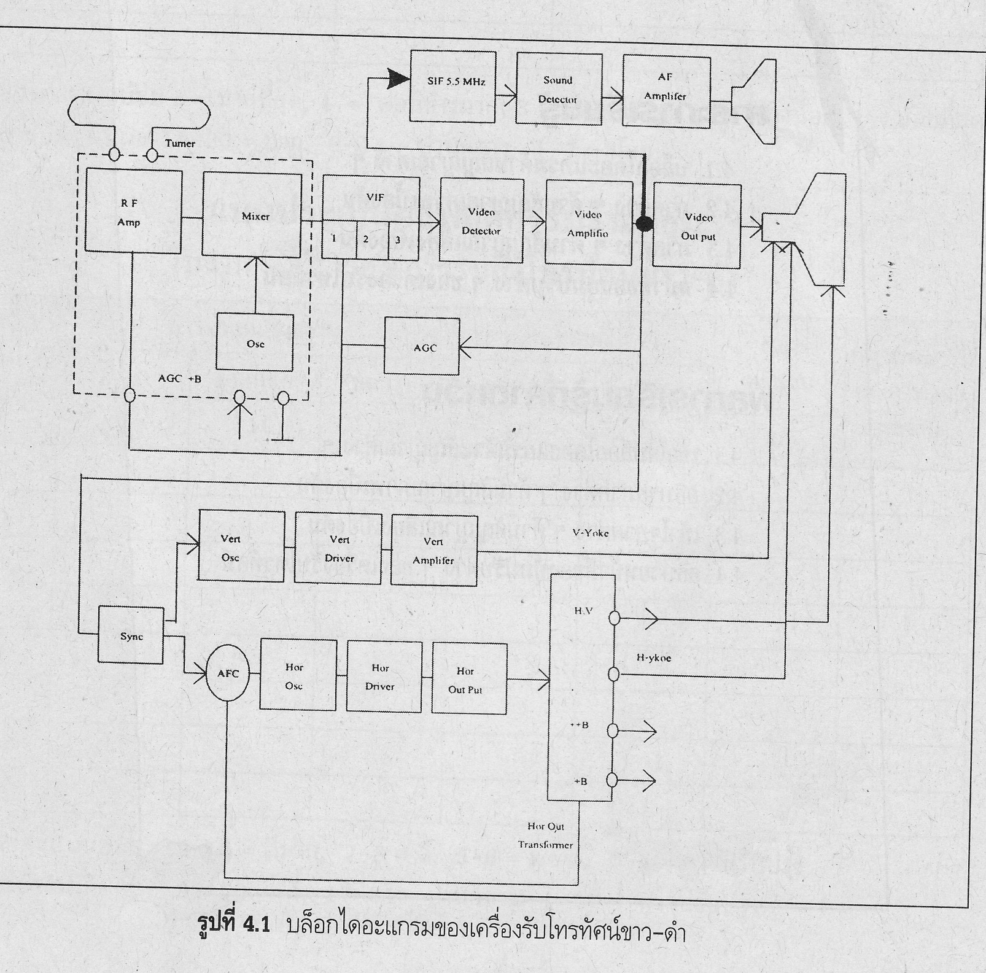

อธิบายแต่ละบล็อก........................................................................................................................................................................
..........................................................................................................................................................................................................
..........................................................................................................................................................................................................
..........................................................................................................................................................................................................
..........................................................................................................................................................................................................
..........................................................................................................................................................................................................
..........................................................................................................................................................................................................
..........................................................................................................................................................................................................
..........................................................................................................................................................................................................
..........................................................................................................................................................................................................
..........................................................................................................................................................................................................
..........................................................................................................................................................................................................
..........................................................................................................................................................................................................
..........................................................................................................................................................................................................
..........................................................................................................................................................................................................
..........................................................................................................................................................................................................
..........................................................................................................................................................................................................
..........................................................................................................................................................................................................
..........................................................................................................................................................................................................
..........................................................................................................................................................................................................
..........................................................................................................................................................................................................
..........................................................................................................................................................................................................
..........................................................................................................................................................................................................
..........................................................................................................................................................................................................
..........................................................................................................................................................................................................
..........................................................................................................................................................................................................
..........................................................................................................................................................................................................
..........................................................................................................................................................................................................
..........................................................................................................................................................................................................
..........................................................................................................................................................................................................
..........................................................................................................................................................................................................
..........................................................................................................................................................................................................
..........................................................................................................................................................................................................
..........................................................................................................................................................................................................
..........................................................................................................................................................................................................
..........................................................................................................................................................................................................
..........................................................................................................................................................................................................
..........................................................................................................................................................................................................
..........................................................................................................................................................................................................
2. ตอบค่าต่างๆ ของระบบ TV ต่อไปนี้
2.1) ระบบ PAL มีการสแกนกี่เส้น .....................................................................................................
2.2) 1 เฟรม เท่ากับ......................................คือ.....................................................................................
2.3) ความถี่ Video IF เท่ากับ..............................................Hz
2.4) ความถี่ Sound IF เท่ากับ..............................................Hz
2.5) ภาค Oscillator จะผลิตความถี่ อย่างไร...........................................................................................
............................................................................................................................................................
2.6) ความถี่ Vertical Oscillator ซอว์ทูธ เท่ากับ..............................................Hz
2.7) ความถี่ Horizontal Oscillator ซอว์ทูธ เท่ากับ..............................................Hz
2.8) ความถี่ Sound IF ที่เข้าภาค Sound Detector เท่ากับ..............................................Hz
2.9) ความถี่ที่ Fly Back ทำงาน เท่ากับ..............................................Hz
2.10) สัญญาณภาพถูกผสมสัญญาณแบบ............................................................................................
2.11) สัญญาณเสียงถูกผสมสัญญาณแบบ............................................................................................
2.12) ภาค AGC คือ..........................................................................................................อย่างไร.......
...........................................................................................................................................................
2.13) ภาค AFC คือ...........................................................................................................อย่างไร.......
...........................................................................................................................................................
2.14) ภาค RF Amp ทำงานอย่างไร.......................................................................................................
...........................................................................................................................................................
2.15) ภาค AF Amp ทำงานอย่างไร.......................................................................................................
...........................................................................................................................................................
2.16) ระบบโทรทัศน์ในปัจจุบัน จงอธิบาย ต่อไปนี้
CCFL LCD TV คือ.............................................................................................................................
...........................................................................................................................................................
EDGE LED TV คือ.............................................................................................................................
...........................................................................................................................................................
Full LED TV คือ.................................................................................................................................
...........................................................................................................................................................
RGB LED TV คือ...............................................................................................................................
...........................................................................................................................................................

